- A psychologist examines the potential relationship between a person's anxiety level and the number of externalizing behaviors (i.e. "acting out" episodes). Data were collected from 10 individual. The anxiety level was measured with a clinical assessment instrument and can be treated as a continuous variable, along with the number of externalizing behaviors in the past month. What type of graph is appropriate to examine the relationship between these two variables?
Subject ID # | Externalizing | Anxiety
1 | 9 | 37
2 | 7 | 23
3 | 7 | 26
4 | 3 | 21
5 | 11 | 42
6 | 6 | 33
7 | 2 | 26
8 | 6 | 35
9 | 6 | 23
10 | 9 | 28

 |  | Pie chart
 |  | Scatter plot
 |  | Histogram
 |  | Bar graph
1 points

QUESTION 2
- What does the following graph suggest?
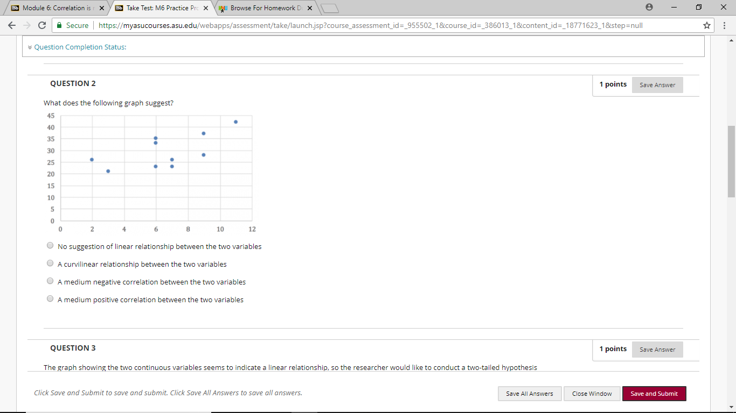
No suggestion of linear relationship between the two variables
A curvilinear relationship between the two variables
A medium negative correlation between the two variables
A medium positive correlation between the two variables
1 points

QUESTION 3
- The graph showing the two continuous variables seems to indicate a linear relationship, so the researcher would like to conduct a two-tailed hypothesis test with correlational analysis. What would be the null hypothesis?
There is a significant difference between anxiety level and externalizing behavior.
There is not a significant correlation between anxiety level and externalizing behavior.
There is a significant correlation between anxiety level and externalizing behavior.
There is not a significant difference between anxiety level and externalizing behavior.
1 points

QUESTION 4
- A correlational analysis can be calculated as the pattern of how the two variables change in value. Because the two variables are on different measurements, the scores need to be converted into Z scores so the variables can be examined together. To calculate Z scores, we need the mean and standard deviation for each variable. Enter the standard deviation for anxiety level. (Round the answer to 2 decimal places)
Subject ID # | Externalizing | Anxiety
1 | 9 | 37
2 | 7 | 23
3 | 7 | 26
4 | 3 | 21
5 | 11 | 42
6 | 6 | 33
7 | 2 | 26
8 | 6 | 35
9 | 6 | 23
10 | 9 | 28

- 
1 points

QUESTION 5
- A correlational analysis can be calculated as the pattern of how the two variables change in value. Because the two variables are on different measurements, the scores need to be converted into Z scores so the variables can be examined together. To calculate Z scores, we need the mean and standard deviation for each variable. Enter the standard deviation for externalizing behavior. (Round the answer to 2 decimal places)
Subject ID # | Externalizing | Anxiety
1 | 9 | 37
2 | 7 | 23
3 | 7 | 26
4 | 3 | 21
5 | 11 | 42
6 | 6 | 33
7 | 2 | 26
8 | 6 | 35
9 | 6 | 23
10 | 9 | 28
- 
1 points

QUESTION 6
- Calculate the correlation coefficient r value using the Z scores for the two variables. (Round the answer to 2 decimal places)

1 points

QUESTION 7
- Explain the direction and strength of the correlation based on the r value.
There is a medium to strong positive correlation between anxiety level and externalizing behavior.
There is a medium to strong negative correlation between anxiety level and externalizing behavior.
There is a weak or medium negative correlation between anxiety level and externalizing behavior.
There is a weak to medium positive correlation between anxiety level and externalizing behavior.
1 points

QUESTION 8
- What is the proportion of variance shared by anxiety level and externalizing behavior? In other words, how much of the variance in externalizing behavior can be predicted by the variance in anxiety level, or vice versa? (Round the answer to 2 decimal places)

1 points

QUESTION 9
- Using a statistical program, the researcher obtained an r value of .648 and a p value of .043. What is the result of the hypothesis test with a preset alpha level of .05?
The researcher rejects the null hypothesis; there is a significant correlation between anxiety level and externalizing behavior.
The researcher fail to reject the null hypothesis; there is no significant correlation between anxiety level and externalizing behavior.
The researcher rejects the null hypothesis; there is no significant correlation between anxiety level and externalizing behavior.
The researcher fails to reject the null hypothesis; there is no significant correlation between anxiety level and externalizing.
1 points

QUESTION 10
- What is the effect size in this hypothesis test? (Round the answer to 2 decimal places)
1 points

